**Curneu Assessment Round 1**

**Problem Statement 1: DES3 using AWS Lambda and API Gateway**

1.Api Gateway :

Creating an API in AWS Gateway:

The API name is **DESApi.**

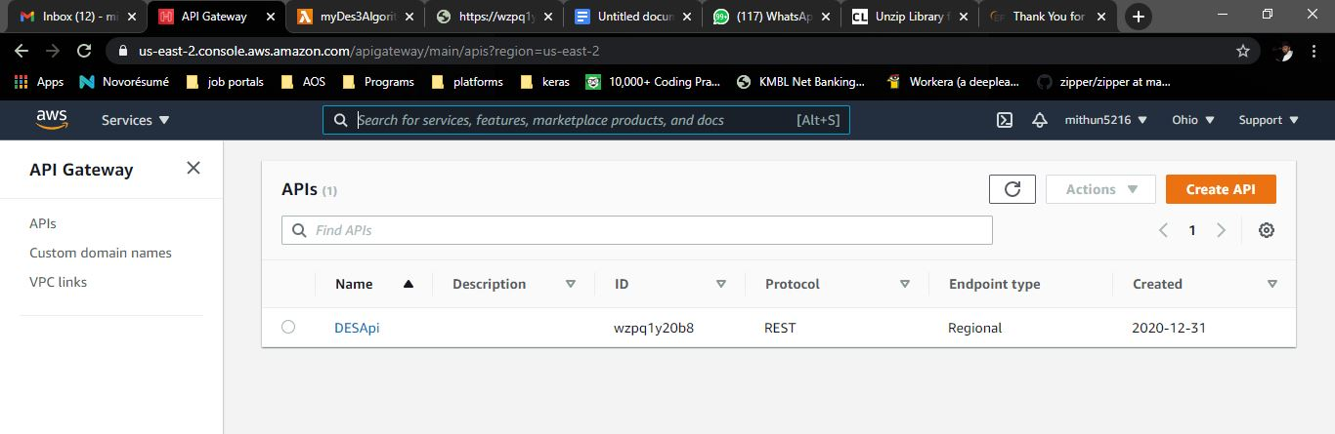

The Api link = <https://wzpq1y20b8.execute-api.us-east-2.amazonaws.com/DES3/tripledes?plainText=please%20encrypt%20my%20data>

Pass a plain text to this API to get the Encrypted Text.

2.Get Method:

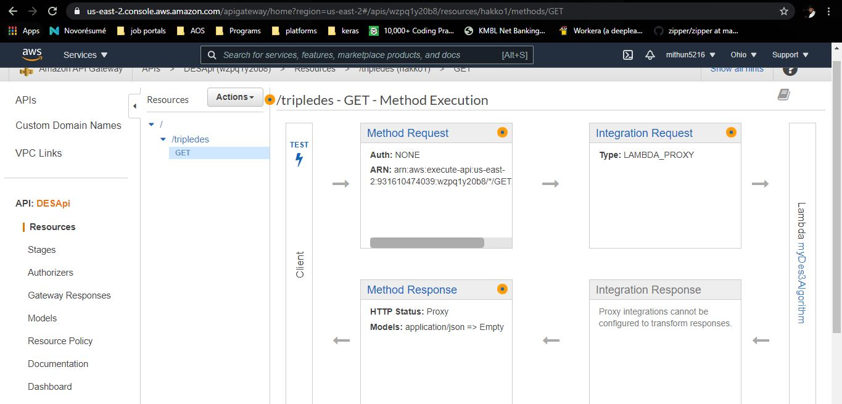

The get method to Create the resource and the methods to link the API with the lambda function.

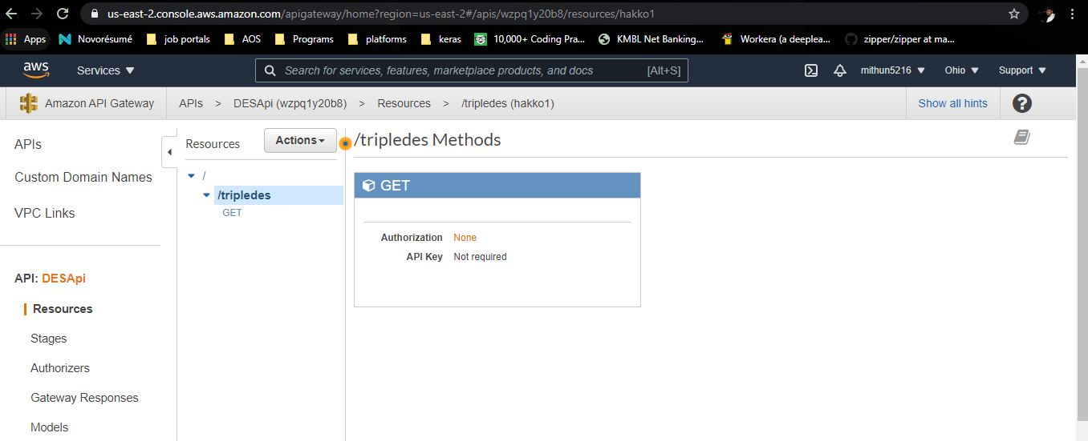

I’ve set the get method to be open and no key.

3.Browser view:

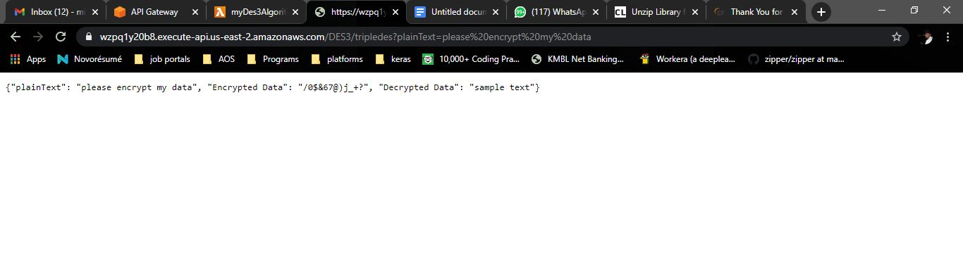

The browser shows the plaintext,encrypted text and the decrypted text.

4.Lambda Function:

The name of the function created in AWS Lambda is myDESAlgorithm.

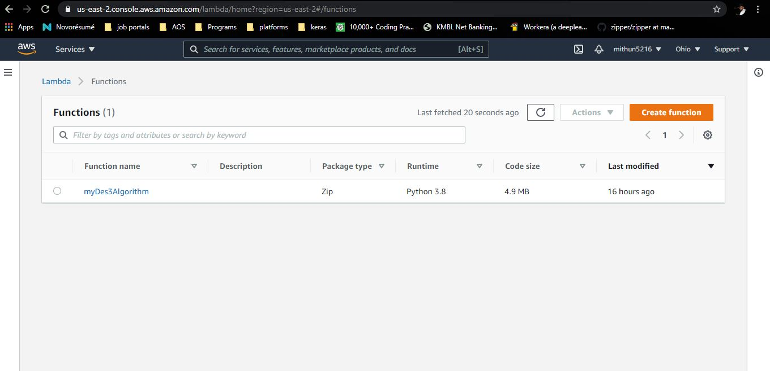

The code in the lambda function can’t be seen as the folder is too long and inline code editing is not possible in this.

5.Powershell:

Created a separate virtual environment and installed the python package Pydes. This package can be imported to use the DES methods.

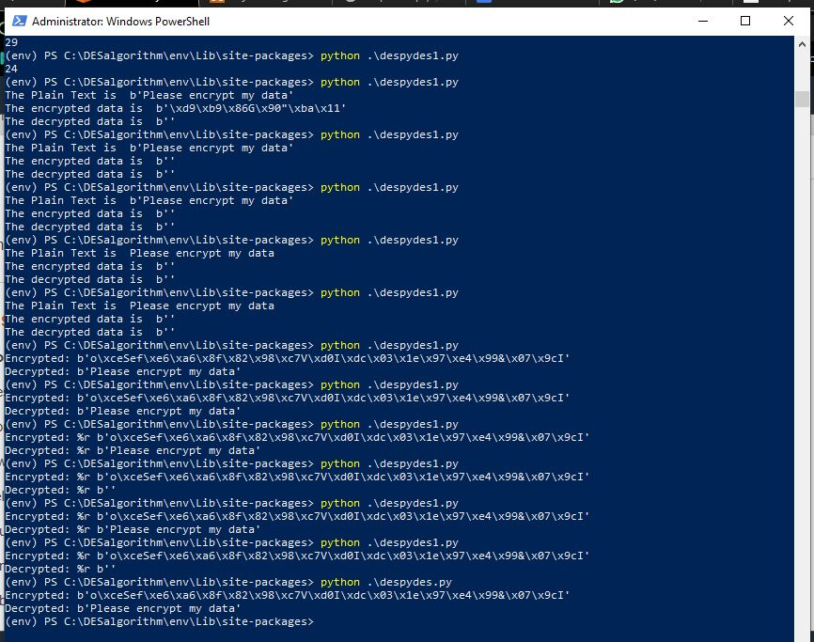

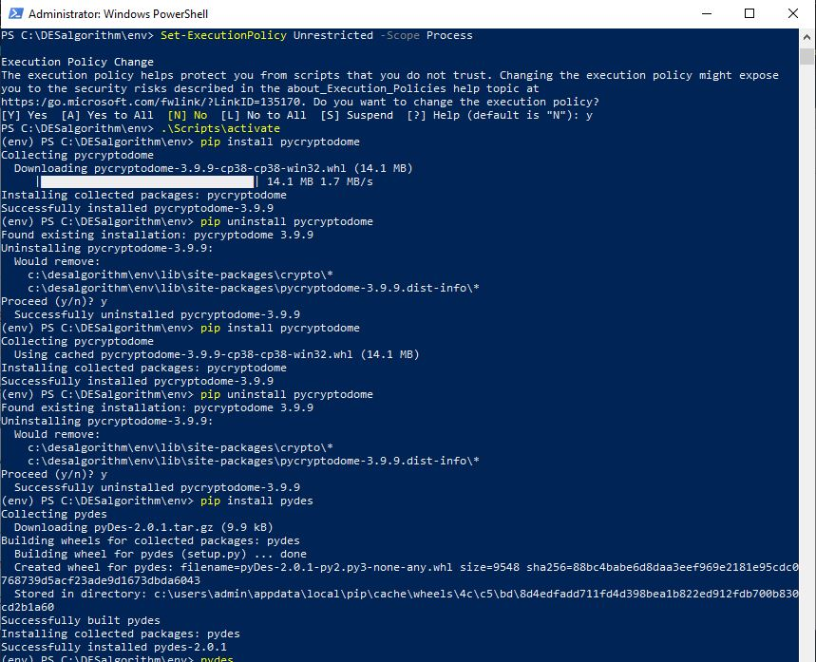

Packges which can be used to implement DES are

Pycryptodome

Pycrypto

PyDes

6.desPydes.py

The code that implements the PyDes package and gives the encrypted text.

Note:

The entire folder has to be zipped and uploaded to the lambda function in order to avoid any module not found error.

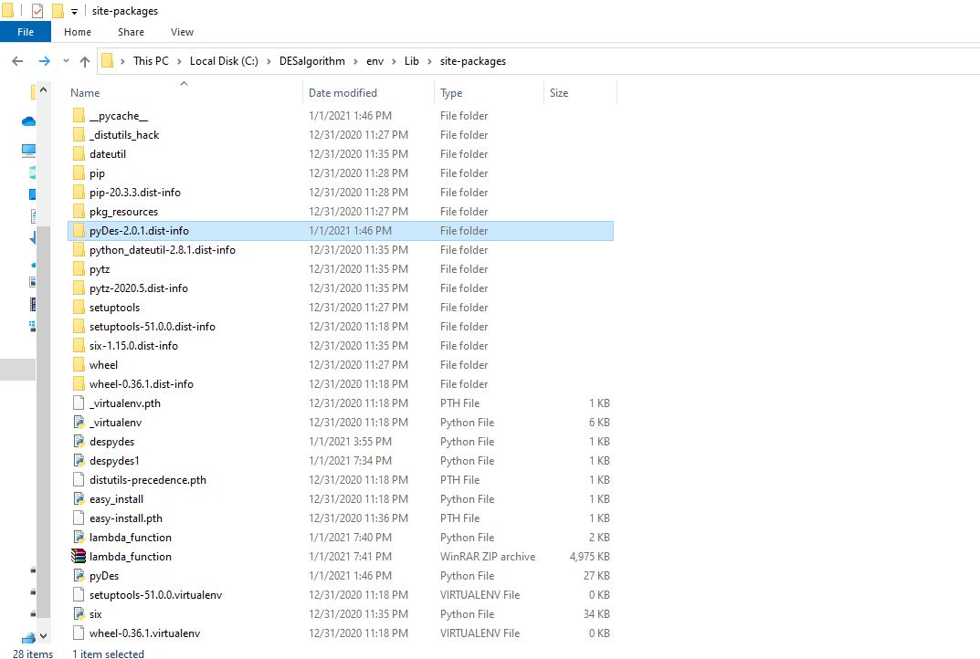

The folder should contain the packages used in the lambda function. The zip name of the folder has to be lambda function as we have invoked the lambda function.

**Problem Statement 2: Unzip a file using Zlib**

Packages used:

Zlib

Msys shell

Mingw64 compiler

1.Input text

The input text file which will be zipped and sent to the program. The format must be tar.gz. For windows we can use 7-Zip to convert any files to tar.gz format.

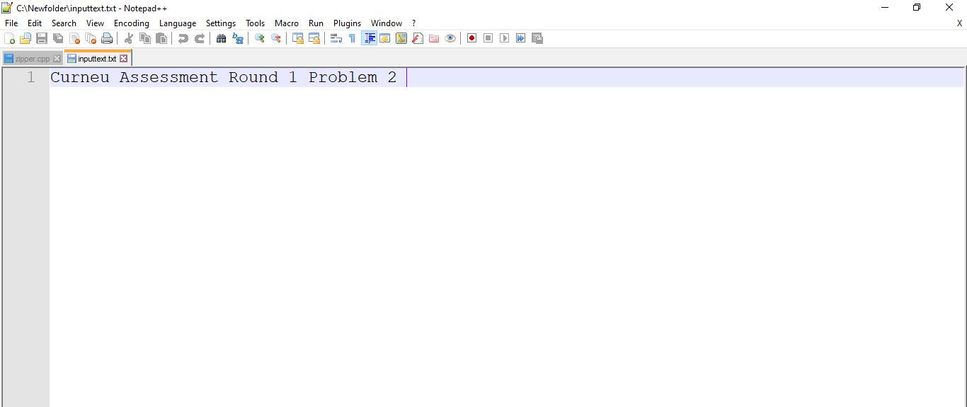

Install the Zlib and msys respectively to implement the Zipper function.

2.msys shell:

The input text file is extracted and the data inside the file is printed.

